Packet Tracer Multiuser - Implement Services

1. Topology

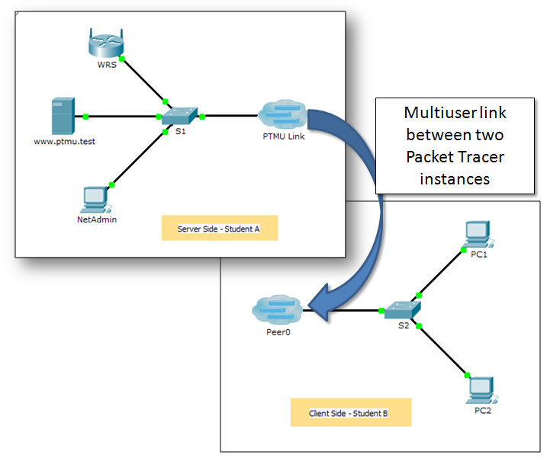

1. Addressing Table

|  |  |  |
| --- | --- | --- |
| Device | IP Address | Subnet Mask |
| **Server Side Player** | | |
| WRS | 172.16.1.254 | 255.255.255.0 |
| S1 | 172.16.1.1 | 255.255.255.0 |
| www.ptmu.test | 172.16.1.5 | 255.255.255.0 |
| NetAdmin | DHCP Assigned | DHCP Assigned |
| **Client Side Player** | | |
| S2 | 172.16.1.2 | 255.255.255.0 |
| PC1 | DHCP Assigned | DHCP Assigned |
| PC2 | DHCP Assigned | DHCP Assigned |

Objectives

Part 1: Establish a Local Multiuser Connection to another Instance of Packet Tracer

Part 2: Server Side Player - Implement and Verify Services

Part 3: Client Side Player - Configure and Verify Access to Services

1. Background

**Note:** Completing the prior activities in this chapter, including the **Packet Tracer Multiuser - Tutorial**, are prerequisites to completing this activity.

In this multiuser activity, two students (players) cooperate to implement and verify services including DHCP, HTTP, Email, DNS, and FTP. The server side player will implement and verify services on one server. The client side player will configure two clients and verify access to services.

1. Establish a Local Multiuser Connection to Another Instance of Packet Tracer
   1. Select a partner and determine the role for each student.
      1. Find a fellow classmate with whom you will cooperate to complete this activity. Your computers must both be connected to the same LAN.
      2. Determine which of you will play the server side and which of you will play the client side in this activity.
   2. The server side player opens **Packet Tracer Multiuser - Implement Services - Server Side.pka**.
   3. The client side player opens **Packet Tracer Multiuser - Implement Services - Client Side.pka**.

**Note:** Solo players can open both files and complete the steps for both sides.

* 1. Configure the switches with initial configurations.

Each player: configure your respective switch with the following:

* Hostname using the display name (**S1** or **S2**).
* An appropriate message-of-the-day (MOTD) banner.
* Privileged EXEC mode and line passwords.
* Correct IP addressing, according to the Addressing Table.
  1. Server Side Player - Configure the PTMU link and communicate addressing.
     1. Complete the steps necessary to verify that the **PTMU Link** is ready to receive an incoming connection.
     2. Communicate the necessary configuration information to the client side player.
  2. Client Side Player - Configure the outgoing multiuser connection.
     1. Client side player: Record the following information supplied to you by the server side player:

IP Address: _________________________________________

Port Number: ________________________________________

Password (**cisco**, by default) ___________________________

* + 1. Configure **Peer0** to connect to the server side player’s **PTMU Link**.
    2. Connect the **S2** **GigabitEthernet0/1** to **Link0** on **Peer0**.
  1. Verify connectivity across the local multiuser connection.
     1. The server side player should be able to ping S2 in the client side player’s instance of Packet Tracer.
     2. The client side player should be able to ping S1 in the server side player’s instance of Packet Tracer.

1. Server Side Player - Implement and Verify Services
   1. Configure WRS as the DHCP server.

**WRS** provides DHCP services. Configure DHCP Server Settings with the following:

* Starting IP address is **172.16.1.11**.
* Maximum number of users is **100**.
* **Static DNS 1** is **172.16.1.5**.
* Verify **NetAdmin** received IP addressing through DHCP.
* From **NetAdmin**, access User Account Information web page at **172.16.1.5**. You will use this information to configure user accounts in Step 2.
  1. Configure services on www.ptmu.test.

The **www.ptmu.test** server provides the rest of the services and should be configured with the following:

* A DNS record associating the IP address for **www.ptmu.test** server to the name www.ptmu.test.
* Email services and user accounts according to the user list. The Domain Name is **ptmu.test**.
* FTP services and user accounts according to the user list. Give each user permission to write, read, and list.
  1. Verify that all services are implemented according to the requirements.

From **NetAdmin**, complete the following:

* Configure the email client for the NetAdmin user account.
* Send an email to the user at **PC1**.
* Upload the **secret.txt** file to the FTP server. Do not change the file.

**Note**: The score for the server side player will be **43/44** until the client side player successfully downloads the **secret.txt** file, modifies the file, and then uploads it to the **www.ptmu.test** FTP server.

1. Client Side Player - Configure and Verify Access to Services
   1. Configure and verify PC addressing.
      1. Configure **PC1** and **PC2** to automatically obtain addressing.
      2. PC1 and PC2 should be able to access the web page **http://www.ptmu.test**.
   2. Configure and verify PC email accounts.
      1. Configure email accounts according to the requirements at **www.ptmu.test/user.html**.
      2. Verify that PC1 received an email from NetAdmin and send a reply.
      3. Send an email from PC1 to PC2. **Note:** Scoring will not change.
      4. Verify that PC2 received an email from PC1.
   3. Upload and download a file from the FTP server.
      1. From PC2, access the FTP server and download the **secret.txt** file.
      2. Open the **secret.txt** file, change only the secret word to **apple**, and upload the file.
      3. The server side player score should be **44/44** and the client side player scored should be **33/33**.